**15 June 2022**

Password Generator (Building a basic password generator)

References: [Password Generator Tutorial Video](https://www.youtube.com/watch?v=AjiGVu2xbx8&ab_channel=AyushiRawat)  
[Password Generator Tutorial Documentation](https://medium.com/analytics-vidhya/create-a-random-password-generator-using-python-2fea485e9da9)  
[Compiling Into Executable - 1](https://www.youtube.com/watch?v=bqNvkAfTvIc&ab_channel=CodePalace)  
[Compiling Into Executable - 2](https://stackoverflow.com/questions/63681770/getting-error-when-using-pynput-with-pyinstaller)  
[Prevent Executable to Close](https://stackoverflow.com/questions/3591807/how-can-i-stop-python-exe-from-closing-immediately-after-i-get-an-output)

Firstly, I will need to import random and string packages to use them in my project



Next, I will print a welcome message and ask the user to enter the preferred length of the password. The preferred length of the password will require the user to input an integer.



Next, I will declare the various data used for the password which includes lowercase, uppercase, numbers and symbols as a variable as shown below. I will then create a new variable “all” to combine all the variables I have declared.

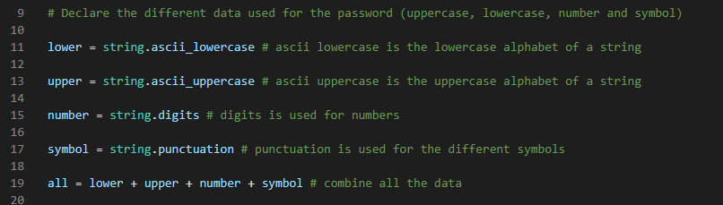

As most accounts require the password to hit a certain length, I created a bool variable that checks the length and assigned it as false



If false, it will ask user for the input of their desired length of password they want to generate. If the length is 8 or below, the user will receive an error message. If the length is more than 8, the user will receive a compliment and the bool variable will be set to true.

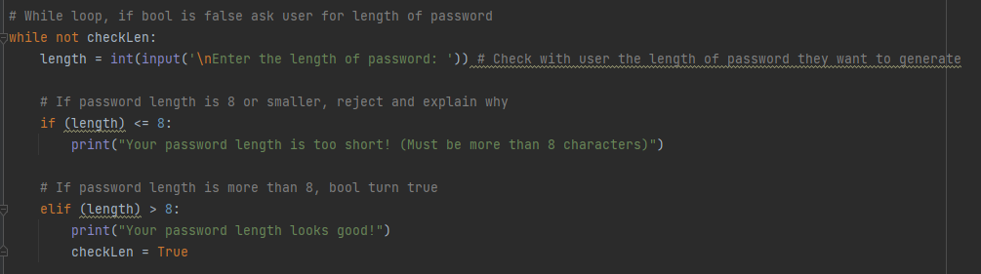

While true, I will create a temporary variable with the random module to generate the password. The random module will consist of 2 parameters, the combined data and the length of the password. As the password generated will be in the form of a string by default, I will use the join method to combine it in to a single string as shown below. Finally, I add the input function to receive an input from the user to close the executable file.

